**SULIMO   
Kenya Certificate of Secondary Education**

**Form 4 Mock exams**

**231/1Biology paper 1 (Theory)**

**JULY 2024 – $2 hours$**

**Name**…………………………………………………..…… **Class**….………….……………….

**Candidate`s Signature**.…………………………………… **Date**…….…….……………………

MARKING SCHEME

Instructions to candidates

1. Write your name and index number in the spaces provided above.
2. Sign and write the date of the examination in the spaces provided above.
3. All questions are compulsory
4. Candidates should answer the questions in English.
5. This paper consists of 8 printed pages. Candidates should check the question paper to ascertain that all the pages are printed as indicated and that no questions are missing

*FOR EXAMINER’S USE ONLY.*

|  |  |  |
| --- | --- | --- |
| Question | Maximum Score | Candidate’s score |
| 1 - 30 | 80 |  |

* 1. State the most suitable biological tool for collecting the following organisms:
     1. Grasshoppers (1 mark)

Sweep net;

* + 1. Termites (1 mark)

Pooter;

* 1. Other than observation, name one other scientific skill developed by studying biology.

(1 mark)

Recording /analyzing/drawing/measuring/evaluating;

1. The table below shows the oxygen consumption and carbon (IV) oxide released at rest by a number of animals under certain conditions.

|  |  |  |  |  |
| --- | --- | --- | --- | --- |
| Animal | Body mass(g) | Carbon (IV) oxide released in cm3 per hour | Oxygen consumption in cm3 per hour | Respiratory Quotient |
| Mouse | 20 | 39 | 40 | 1.0; |
| Dog | 10000 | 1960 | 2800 | 0.7; |

* 1. Complete the table in the last column showing respiratory quotient. (2 marks)
  2. From the completed table above which animal was using the following respiratory substrates; (2 marks)
     1. Fat

Dog;

* + 1. Glucose

Mouse;

* 1. State the type of circulatory system found in members of the class Insecta. (1 mark)

Open circulatory system;

* 1. Name the blood vessels that transport blood from: (2 marks)
     1. Small intestine to the liver

Hepatic portal vein;

* + 1. Lungs to the heart

Pulmonary vein;

1. The diagrams below represent two gynoecia A and B obtained from two different plants.

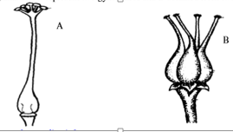

1. What name is given to; (2 marks)
   * 1. Gynoecium A

Syncarpous;

* + 1. Gynoecium B

Apocarpous;

* 1. State one observable difference between the two gynoecia. (1 mark)

In A the ovaries are fused while in B the ovaries are free/not fused;

1. Name one enzyme that is secreted in its precursor form. (1 mark)

Pepsin/rennin/trypsin;

1. State two reasons why the stomach lining is not usually digested by pepsin though the lining is made of protein. (2 marks) Mucus lining;

Enzymes secreted in their inactive/precursor forms;

1. Explain how predators can influence natural selection (2 marks)

Predators feed on prey, prey with desirable traits like being camouflage, is less likely to be preyed upon, hence more likely to survive and reproduce passing their traits to the offspring; preys with undesirable variations are weeded out;

1. The diameter of the field of view of a light microscopic is 6.5 mm. Plant cells lying across the diameter are 12.

Determine the size of one cell in micrometers. (2 marks)

Size of one cell=diameter of field of view=6.5mmX1000=65000=541.66um;

Number of cells 12 12

* 1. Explain how drooping of leaves on a hot sunny day is advantageous to a plant. (2 marks)

Reduces surface area over which transpiration occur leading to lower rate of transpiration;

* 1. A strip of peeled potato whose cell sap concentration was 30% was placed in a petri-dish containing 10% sugar solution.

Account for the observation made after minutes. (2 marks)

The cell sap concentration is hypertonic to the 10 % sugar solution therefore the cells of the potato strip absorbed water molecules by osmosis leading to turgidity of the cells and firmness of the strip;

* 1. What causes diabetes insipidus (1 mark)

Inability of the pituitary gland to produce enough ADH;

* 1. A doctor suspects that their patient has diabetes mellitus. How can this be determined in a school laboratory (2 marks)

Put 2 ml of the patient urine in a test tube, add 2 ml of Benedict’s reagent and heat to boil; green/yellow/brown/orange/red colour indicate presence of glucose in urine hence the person has diabetes mellitus;

* 1. Explain why specimens are collected and preserved in specimen bottles. (1 mark)

Further study;

* 1. What is binomial nomenclature as used in the naming of living organisms? (1 mark)

The giving of one scientific name to an organism, that has two parts, genus and species part;

* 1. Give a reason why scientific names are given in Latin. (1 mark)

Latin is stable/static/does not change;

1. Draw a well labelled diagram of a root hair cell (3 marks)

Drawing-1

Labelling-2

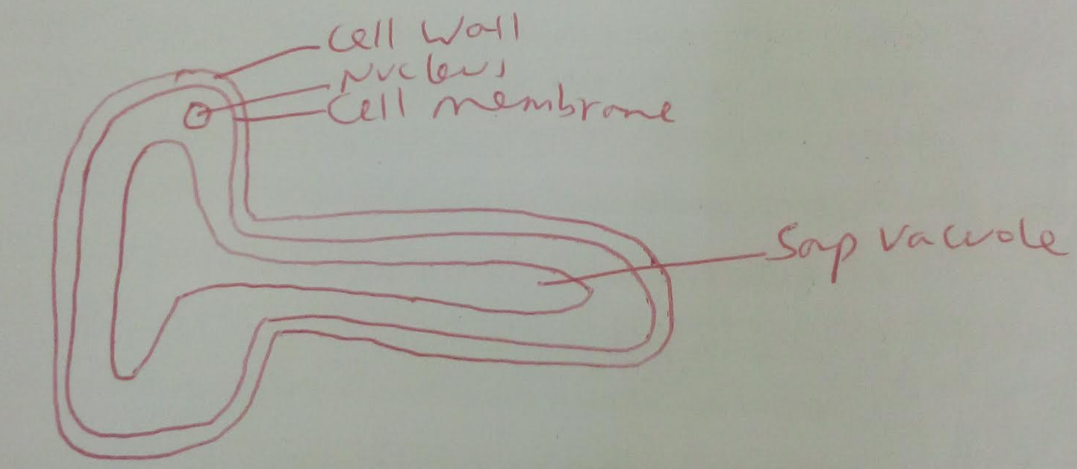

1. 1. What is meant by the term gaseous exchange? (1 mark)

The process by which respiratory gases are passed across respiratory surface;

* 1. Explain why respiratory surfaces are moist. (1 mark)

Dissolve respiratory gases;

1. An organism was found to have a dental formula.

i 0/3 c0/1 pm3/2 m3/3 = 30

1. State the mode of feeding of the organism (1 mark)

Herbivorous;

1. Give a reason for your answer in (a) above. (1 mark)

Lack of canines/ presence of diastema; lack of incisors on the upper jaw/has horny pad;

1. What is the meaning of each of the following terms (2 marks)
   1. Homeostasis

The maintenance of a constant internal environment;

* 1. Osmoregulation

The maintenance of the water/ionic content of the internal environment;

* 1. Name the hormones involved in regulation of glucose level in the blood (2 marks)

Insulin;

Glucagon;

1. State two structural differences between ribonucleic acid (RNA) and deoxyribonucleic acid (DNA). (2 marks)

DNA is double stranded while RNA is single stranded;

DNA contains deoxyribose sugar while RNA contains ribose sugar;

DNA contains thymine base while RNA contains uracil base;

1. The diagram below represents a tissue obtained from a mammal.

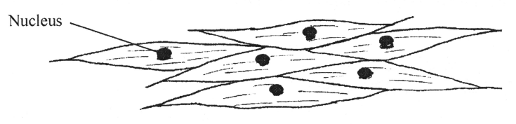

1. Identify the tissue (1 mark)

Smooth muscle tissue;

1. Name one organ in which the above tissue is found. (1 mark)

Stomach/ileum/duodenum/oviduct/artery/vein; accept any internal tubular organ;

1. State two adaptations of the tissue to its function. (2 marks)

Contains many mitochondria to provide energy for contraction;

Contains contractile fibrils that lead to contraction and relaxation;

1. The following is an equation representing a type of respiration.

C6H12O6 2C3H6O3 + ATP

* 1. Identify the type of respiration. (1 mark)

Anaerobic respiration;

* 1. Suggest one industrial application of the process named in (a) above. (1 mark)

Bread/wine/beer/silage making;

1. Name any one physiological process in plants that may be affected by dust as a pollutant.

(1 mark)

Gaseous exchange/Transpiration/Respiration/photosynthesis;

1. 1. Name the causative agent for amoebic dysentery. (1 mark)

*Entamoeba histolytica;*

* 1. State two preventive measures of schistosomiasis in human beings (2 marks)

Proper (sanitary) disposal of faeces and urine/use of deep pit latrines/flash toilets for disposal of faeces and Urine;

All drinking water boiled/chemically treated to kill the eggs/miracidia/cercariae;

People should not bath/swim in water infested with snails;

People should wear protective shoes/water proof shoes/gumboots when walking in waters infested with snails/swampy areas;

Spray water infested with snails with molluscicides;

1. State how pollution from the following pollutants can be controlled.
   1. Oil spillage (1 mark)

Using pipeline to transport oil;

* 1. Industrial effluents (1 mark)

Treating the industrial effluents before discharging into water bodies;

* 1. Inorganic fertilizers (1 mark)

Using the correct amount of inorganic fertilisers/using organic fertilisers;

1. The figure below represents a unicellular organism.

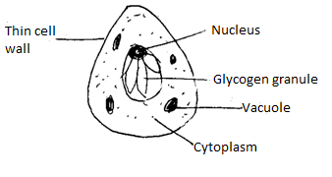

* 1. State the mode of nutrition exhibited by the organism (1 mark)

Saprotrophic nutrition/saprophytism;

* 1. Name the kingdom to which it belongs (1 mark)

Fungi;

* 1. State one feature common to members of the kingdom named in (b) above. (1 mark)

No chloroplast/chlorophyll;

* 1. Name the part of an enzyme where substrate molecules fix themselves during an enzyme catalyzed reaction (1 mark)

Active site;

* 1. State what would happen to an enzyme if the temperature is
     1. Raised above optimum (1 mark)

Denatured;

* + 1. Lowered below 100C (1 mark)

Enzyme becomes less active;

* 1. What is seed dormancy? (1 mark)

The state in which seed is unable to germinate, even under ideal growing conditions;

* 1. Name a growth inhibitor in seeds (1 mark)

Abscisic acid;

1. The diagram below shows a phenomenon which occurs during cell division.

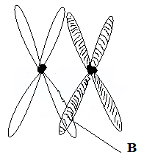

* 1. Identify the stage of cell division in which this phenomenon occurs. (1 mark)

Prophase I;

* 1. State the importance of the phenomenon-taking place in the part labeled B. (2 marks)

Crossing over occurs leading to variation;

* 1. What is meant by the term Genetically Modified Organism (GMO)? (1 mark)

These are organisms whose gene arrangement has been changed through genetic engineering to produce new organisms with unique characteristics;

* 1. Name one area in Medicine where knowledge of Genetic Engineering has been successfully applied. (1 mark)

Treatment of cystic fibrosis/production of vaccines/insulin;

1. The illustration below shows a transverse section through a mammalian kidney.

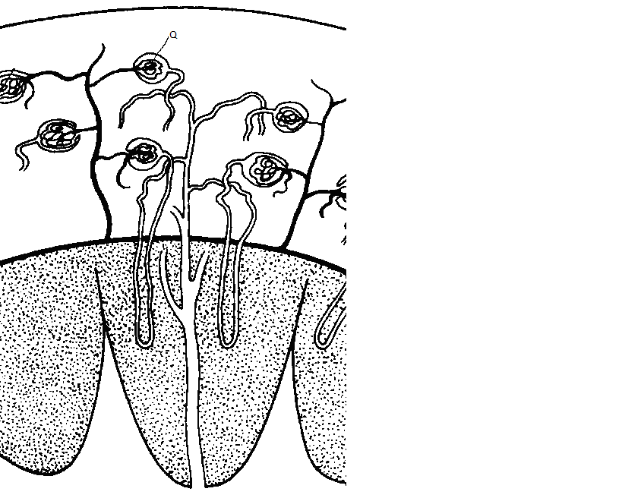

**Y**

**X**

* 1. Name the structures labelled X and Y. (2 marks)

X: Cortex;

Y: Medulla;

* 1. State the process in Q that leads to the formation of glomerular filtrate. (1 mark)

Ultrafiltration;

1. The diagram below shows one of the cell organelles.

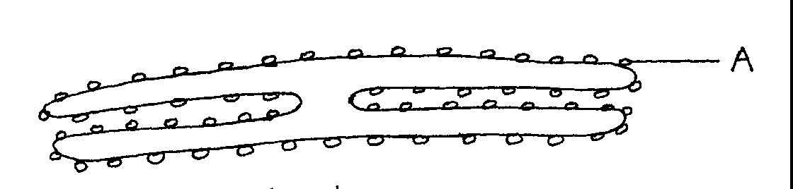

* 1. Identify the organelle (1 mark)

Rough endoplasmic reticulum;

* 1. Give the function of the part of the organelle marked A. (1 mark)

Provide site of protein synthesis;

1. State two characteristics of meristematic cells. (2 marks)

Thin cell wall;

Lack vacuoles;

Dense cytoplasm;

Prominent nucleus;

Mark the first two

1. During a study, 48 larvae were put in unpainted side of the petri dish as shown below.

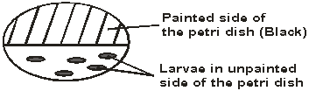

The Petri-dish was left in bright sunshine, the number of larvae on unpainted side was counted every minute for five minutes, and the results obtained were as shown below.

|  |  |  |
| --- | --- | --- |
| Time (min) | Number of larvae | |
| In painted side | In unpainted side |
| 0 | 25 | 25 |
| 1 | 30 | 20 |
| 2 | 36 | 14 |
| 3 | 45 | 5 |
| 4 | 49 | 1 |
| 5 | 48 | 0 |

1. What conclusion can you draw from these results about the behaviour of the larvae?

(1mark)

The show a positive phototaxis;

1. Name the response exhibited by the larvae. (1 mark)

Positive phototaxis;

1. What is the survival value of this behaviour to the larvae? (2 marks)

Enable the larvae to escape high light intensity; thus prevent excessive loss of water/desiccation;